Emilia Mickevicius

The Photo League (group; active 1936-1951) Word Count: 509
The Photo League was a cooperative of photographers in New York who were united by shared social and creative motivations. Its members included Morris Engel, Sid Grossman, Helen Levitt, Walter Rosenblum, Aaron Siskind, Paul Strand, and Weegee. Other figures who supported the group but were not members included Berenice Abbott, Ansel Adams, Margaret Bourke-White, Dorothea Lange, Lisette Model, and Beaumont Newhall. The League was active from 1936 to 1951, and held regular meetings throughout its duration, as well as events, lectures, and symposia to promote education in photography skills and techniques. It also maintained darkroom facilities and an exhibition space in New York, initially on 21st Street and later on 10th Street. Joining social and political efficacy with a dedication to aesthetic standards, and in an environment that stressed creative collaboration, members of the Photo League produced imagery that contributed to the development of documentary practice within the greater creative and cultural ferment of the 1930s. On December 4th, 1942, the Photo League was included on the list of “subversive” organizations submitted by U.S. Attorney General Tom C. Clark to President Harry S. Truman. The League denied the charges in a press release, and further challenged their blacklisting in a telegram sent directly to Attorney General Clark. Under this pressure, they ceased activity in 1951.
As the outgrowth of an intricate network of organizations, the Photo League traces its genealogy to the Workers International Relief (WIR). This American chapter of the Berlin-based Internationale Arbeiterhilfe (IAH) was supported by the Communist International, and established the Worker’s Camera League in New York City in 1930. Politically pro-union and anti-fascist, the Worker’s Camera League became known as the Worker’s Film and Photo League (WFPL). Taking cues from Soviet cinema, the collective of filmmakers, photographers, writers, and projectionists produced creative material that addressed the struggles of the American working class. Two factions eventually formed to address the needs of still photographers and filmmakers separately. Paul Strand and board member Berenice Abbott spearheaded the still-photography group in 1936 and called it The Photo League.
The Photo League did not advocate a particular visual style, though members generally committed to urban social documentation presented in clear, sharply defined images. With the invention of faster film and the marketing of small handheld cameras such as the Leica in the early 1920s, photographers had become better equipped to record passing moments on the street. Emblematic of the street photography produced by the League are the photographs of Helen Levitt and Weegee, as well as the collaborative projects of Aaron Siskind.
References and Further Reading
Creative Camera, nos. 223 and 224 (July/August 1983). Special issue devoted to the Photo League.
History of Photography Vol. 18, No. 2 (Summer 1994). Special issue devoted to the Photo League.
International Center of Photography. “The Photo League: Harlem Document and Related Works.” http://www.icp.org/museum/exhibitions/photo-league-harlem-document-and-related-works
The Jewish Museum, New York and the Columbus Museum of Art. The Radical Camera: New York’s Photo League, 1936-1951. New Haven: Yale University Press, 2011.
New York Public Library. “Where Do We Go From Here? The Photo League and Its Legacy, 1936-2006.” http://web-static.nypl.org/exhibitions/league/index.html

Visual Material:
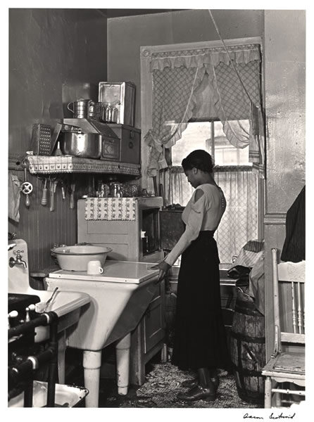
Aaron Siskind, Harlem Lady in a Kitchen, 1940
Gelatin Silver Print
International Center of Photography
ICP 98.1981
http://museum.icp.org/museum/exhibitions/photo_league/images/introduction.htm

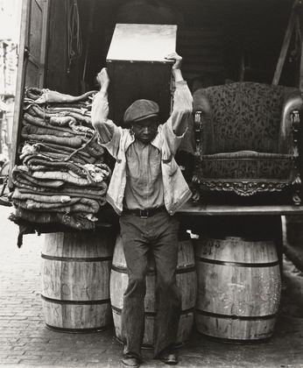
Walter Rosenblum, Moving Man, Pitt Street, Lower East Side, 1938
Gelatin silver print
Museum of Modern Art, New York
1949.2008
http://www.moma.org/collection/object.php?object_id=118994

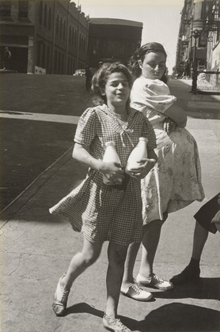
Helen Levitt, New York, 1940 (NOTE: this date is from the Art Institute of Chicago, but MoMA’s website says ca. 1945. Since the AIC says definitively 1940, that is the date I chose to use).
Gelatin silver print
The Art Institute of Chicago
2000.166
http://www.artic.edu/aic/collections/artwork/155671?search_no=5&index=24

